Enquire Purchase Order List
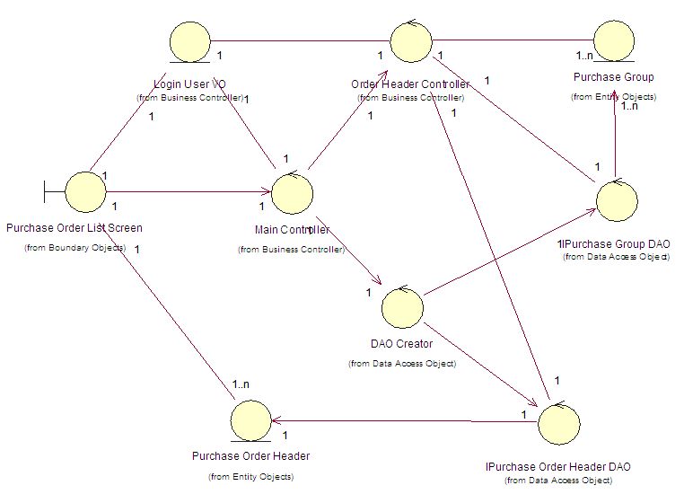

View Purchase Order Details – User Interfaces
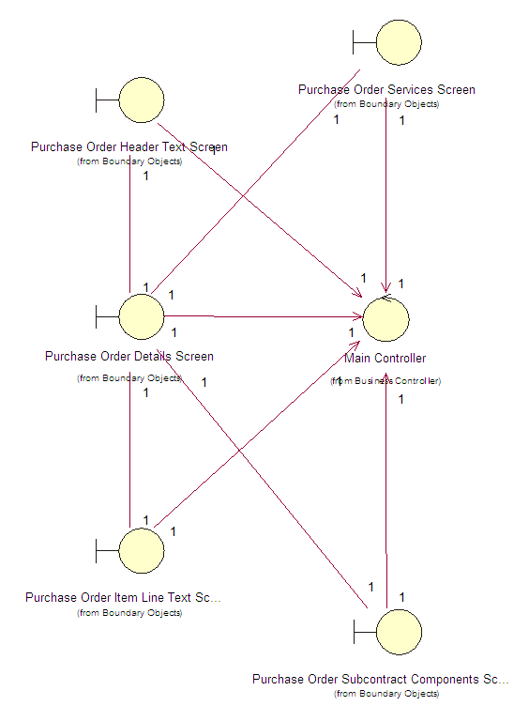

View Purchase Order Details - View Purchase Order Line Items and Schedules
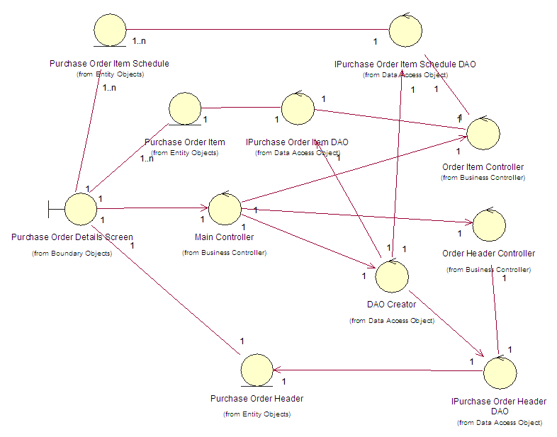

View Purchase Order Details - View Purchase Order Header Text
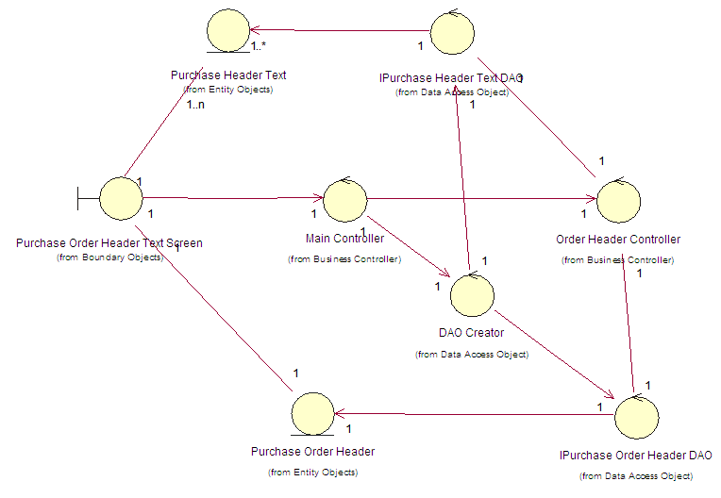

View Purchase Order Details - View Purchase Order Item Line Text
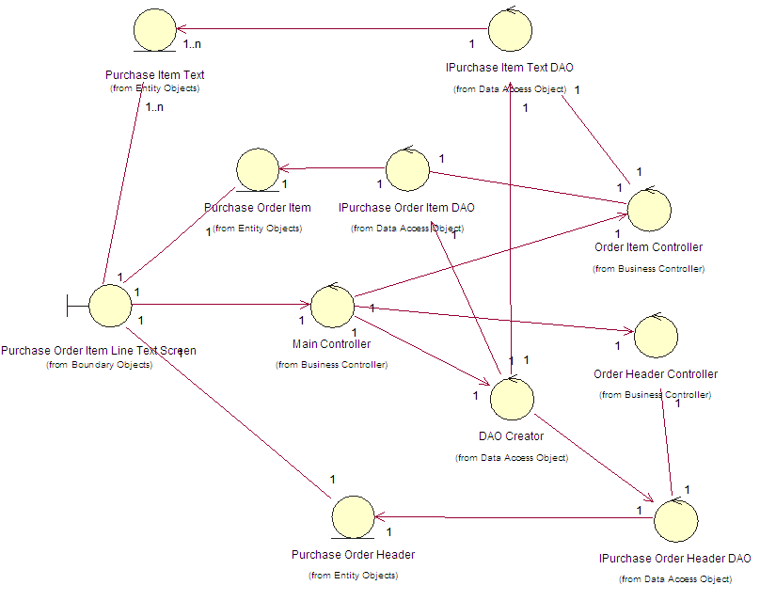

View Purchase Order Details - View Purchase Order Service Items
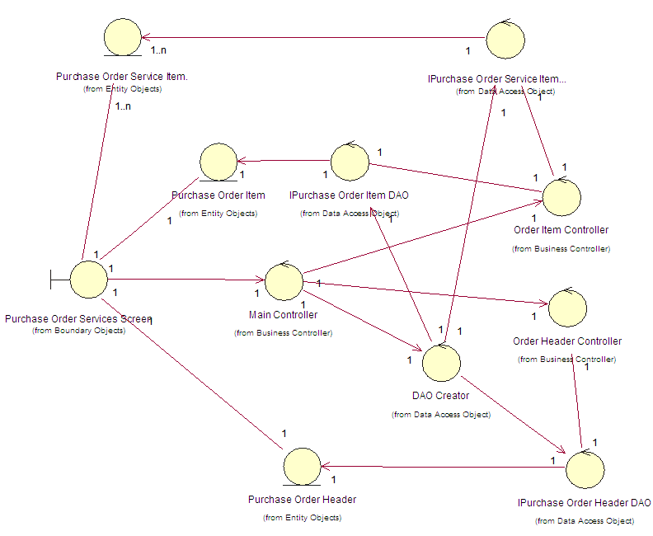

View Purchase Order Details - View Purchase Order Subcontract Components
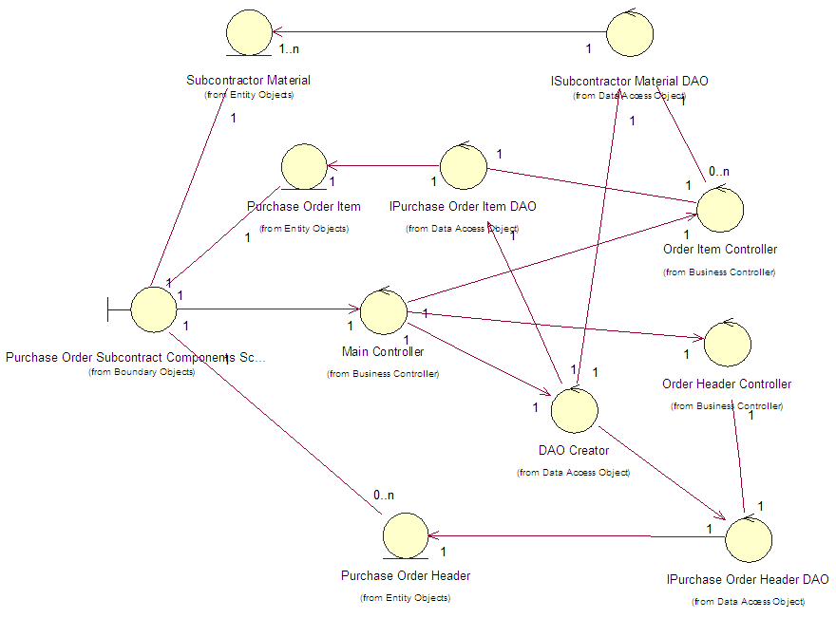

Purchase Order Expediting
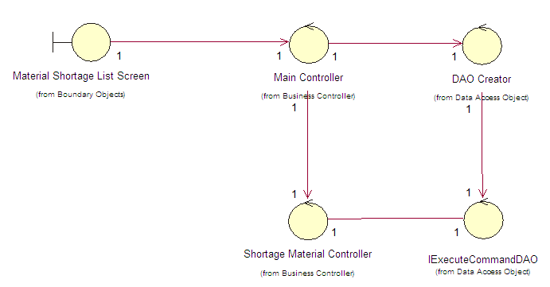

View Shortage List
